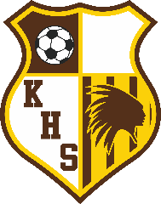

Kickapoo Shootout
2026 Varsity Girls Soccer

THURSDAY APRIL 16TH
12:00pm Rogersville v Smith-Cotton
2:00pm Kickapoo v Jackson
4:00pm Nixa v Rockwood Summit
6:00pm Glendale v Lee’s Summit West
8:00pm Bentonville v Hickman

FRIDAY APRIL 17TH
10:00am Rockwood Summit v Kickapoo
12:00pm Smith-Cotton v Branson
2:00pm Lee’s Summit West v Nixa
4:00pm Jackson v Glendale
6:00pm Hickman v Rogersville
8:00pm Republic v Bentonville

SATURDAY APRIL 18TH
8:00am Kickapoo v Lee’s Summit West Grass
8:00am Nixa v Jackson Turf
10:00am S-C v Rockwood Summit Grass
10:00am Glendale v Hickman Turf
12:00pm Rogersville v Bentonville Grass

31st edition

