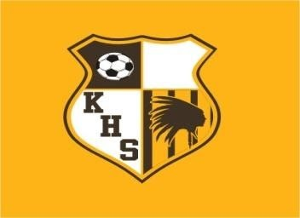
2024 KICKAPOO HIGH SCHOOL
GIRLS SHOOTOUT

TEAMS PARTICIPATING:
Glendale, Harrison, AR; Hickman, Jackson, Kickapoo, Lee’s Summit West, Nixa, Republic, Timberland, Smith-Cotton, Catholic, Rolla, Webb City

THURSDAY APRIL 11
1:00PM CATHOLIC vs SMITH-COTTON
3:00PM NIXA vs JACKSON
5:00PM GLENDALE vs HICKMAN
7:00PM KICKAPOO vs LEE’S SUMMIT WEST

FRIDAY APRIL 12

10:00AM JACKSON vs GLENDALE
12:00PM LSW vs TIMBERLAND
2:00PM HARRISON, AR vs REPUBLIC
4:00PM SMITH-COTTON vs ROLLA
6:00PM HICKMAN vs NIXA
8:00PM TIMBERLAND vs KICKAPOO

SATURDAY APRIL 13

8:00AM LSW vs JACKSON TURF
8:00AM WEBB CITY vs SMITH-COTTON GRASS
10:00AM NIXA vs HARRISON, AR TURF
10:00AM KICKAPOO vs HICKMAN GRASS
12:00PM GLENDALE vs TIMBERLAND GRASS

*Home team listed first
*MSHSAA regular season overtime rules apply

