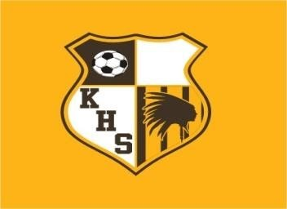

Jamboree March 7th

5:00pm Glendale vs Nixa
5:45pm Kickapoo vs Nixa
6:30pm Kickapoo vs Glendale

