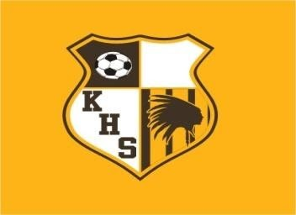

JAMBOREE
MARCH 9th AT KICKAPOO
5:00PM GLENDALE VS NIXA
5:45PM KICKAPOO VS NIXA
6:30PM KICKAPOO VS GLENDALE

