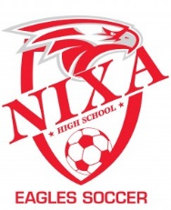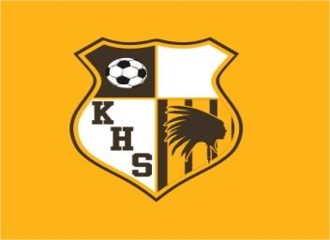

2022 Jamboree
8/23/2022

5pm Nixa vs Glendale
5:45pm Nixa vs Kickapoo
6:30pm Glendale vs Kickapoo

