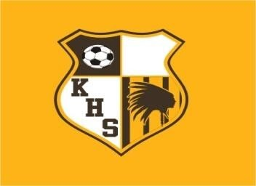

**KICKAPOO HIGH SCHOOL**

**LADY CHIEFS SHOOTOUT 2022**

**THURSDAY APRIL 14TH**

4:00PM KICKAPOO VS JACKSON

6:00PM NIXA VS HARRISON

8:00PM GLENDALE VS HICKMAN

**FRIDAY APRIL 15TH**

2:00PM TIMBERLAND VS NIXA

4:00PM JACKSON VS GLENDALE

6:00PM HICKMAN VS REPUBLIC

8:00PM KICKAPOO VS TIMBERLAND

**SATURDAY APRIL 16TH**

8:00AM JACKSON VS NIXA

10:00AM KICKAPOO VS HICKMAN

12:00PM GLENDALE VS TIMBERLAND

2:00PM REPUBLIC VS HARRISON