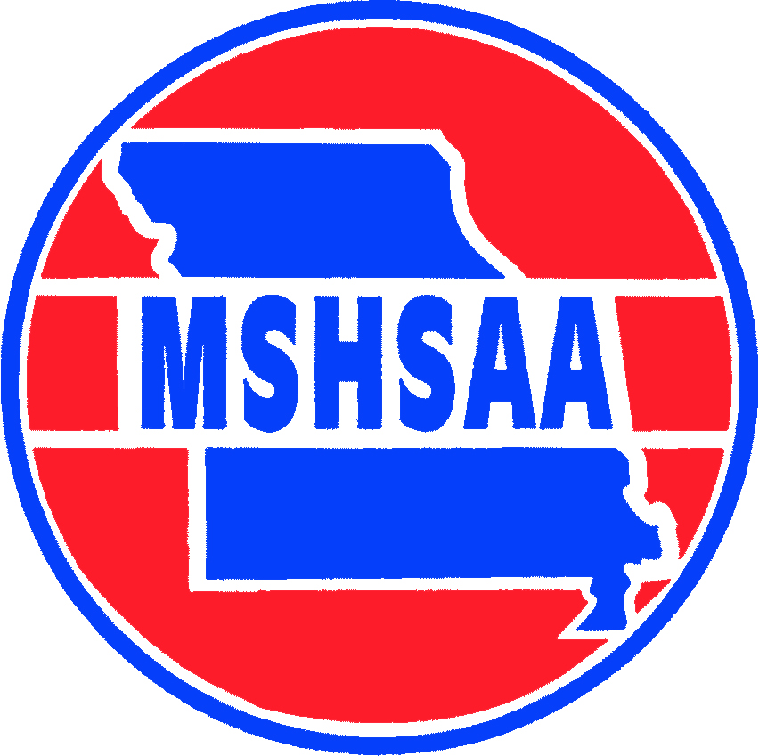
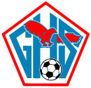 GLENDALE 2021
Date Opponent Order of Play Location Time
August 31 *Lebanon V/JV Lebanon 4:30pm
September 1 Republic JV/V Republic 5:00pm
September 3 SLUH V St. Louis 4:00pm
September 4 Vianney V St. Louis 11:00am
September 7 *Kickapoo JV/V Glendale 5:00pm
September 9 *Rolla JV/V Rolla 5:00pm
September 10 & 11 Carthage JV Tourney JV Carthage tba
September 10 East Kansas City V Glendale 6:00pm
September 11 Northwest V Glendale 7:30am
September 14 *Parkview JV/V Glendale 5:00pm
September 16 Nixa JV/V Nixa 5:00pm
September 21 *West Plains JV/V West Plains 5:00pm
September 22 Ozark JV/V Glendale 5:00pm
September 28 *Waynesville JV/V Glendale 5:00pm
September 30 Chiefs shootout V Kickapoo tba
October 1 Chiefs shootout V Kickapoo tba
October 2 Chiefs shootout V Kickapoo tba
October 5 *Camdenton JV/V Glendale 5:00pm
October 7 Branson JV/V Branson 5:00pm
October 12 *Bolivar JV/V Bolivar 5:00pm
October 14 Carthage JV/V Carthage 5:00pm
October 15 Pembroke Hill V Kansas City 5:00pm
October 20 Jeff City JV/V Glendale 5:00pm
October 21 *Central JV/V Central 5:00pm
October 22 & 23 JV Tournament JV Kickapoo tba
October 26 *Hillcrest V Glendale 5:00pm

