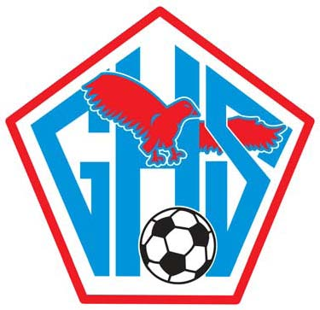

GLENDALE LADY FALCONS
2014 SOCCER BANQUET

Players, Coaches, Family & Friends are invited to celebrate
the 2014 Lady Falcons Soccer season at the annual banquet.

When: Monday, June 2, 2014
Time: 6:00 – 8:30 p.m.
Where: Mille’s Café
313 S. Jefferson Avenue

Menu: Classic Chicken Parmesan Pasta
Roasted Pork Loin with Apricot Honey Glaze
Garlic Mashed Potatoes & Chef’s Vegetables
House Salad with Citrus Ginger Dressing
French Bread, Drinks & Dessert

Cost: $16 per person
(Payment can be mailed to Becky Bright or paid at the banquet)

Players & Coaches are complimentary!

Please RSVP (including players/coaches)
to Becky Bright by Wednesday, May 28
417-840-6128 or rebecca.bright@sbcglobal.net
Mail payments to: 3351 S. Oak Avenue, Springfield, MO 65804

