KICKAPOO HIGH SCHOOL
2020 GIRLS SOCCER TOURNAMENT

WHITE POOL
KICKAPOO ROCKWOOD SUMMIT
GLENDALE JACKSON
NIXA LIBERTY NORTH

THURSDAY APRIL 16TH
4:00PM NIXA VS ROCKWOOD SUMMIT TURF
6:00PM KICKAPOO VS JACKSON TURF
8:00PM ROCKWOOD SUMMIT VS GLENDALE TURF

FRIDAY APRIL 17TH

2:00PM ROCKWOOD SUMMIT VS KICKAPOO TURF
3:00PM GLENDALE VS JACKSON GRASS
6:00PM NIXA VS LIBERTY NORTH TURF

SATURDAY APRIL 18TH

10:00AM JACKSON VS NIXA TURF
10:00AM GLENDALE AT LIBERTY NORTH AT GLENDALE
2:00PM LIBERTY NORTH VS KICKAPOO TURF

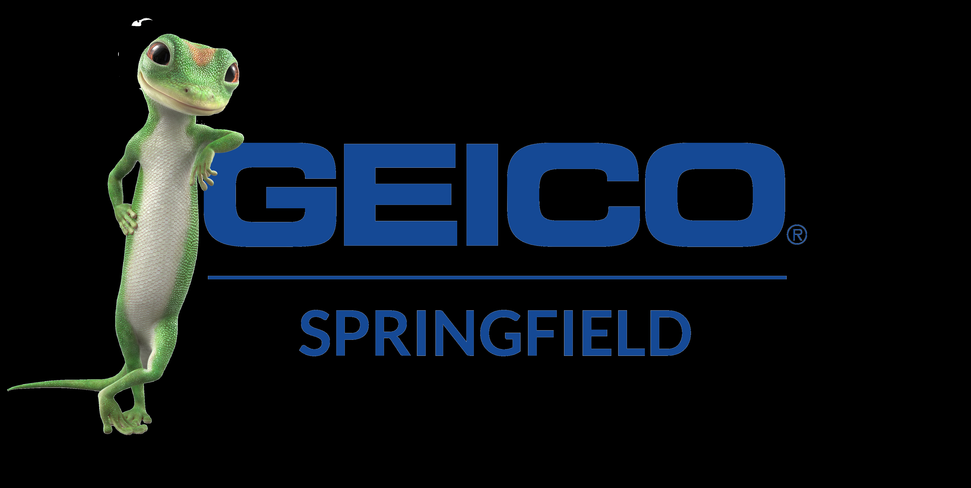
KICKAPOO HIGH SCHOOL
2020 GIRLS SOCCER TOURNAMENT

GOLD POOL
SMITH-COTTON
WILLARD
CARL JUNCTION
JEFFERSON CITY

FRIDAY APRIL 17TH

4:00PM CARL JUNCTION VS JEFFERSON CITY TURF
5:00PM WILLARD VS SMITH-COTTON GRASS

SATURDAY APRIL 18TH

8:00AM CARL JUNCTION VS SMITH-COTTON GRASS
8:00AM JEFFERSON CITY VS WILLARD TURF
12:00PM WILLARD VS CARL JUNCTION GRASS
12:00PM SMITH-COTTON VS JEFFERSON CITY TURF

KICKAPOO HIGH SCHOOL
2020 GIRLS SOCCER TOURNAMENT

BROWN POOL

HARRISON, AR
HICKMAN
SPRINGFIELD CATHOLIC
REPUBLIC
VALLEY VIEW, AR

WEDNESDAY APRIL 15TH

6:00PM HARRISON, AR VS CATHOLIC TURF

FRIDAY APRIL 17TH
7:00PM REPUBLIC VS VALLEY VIEW, AR GRASS
8:00PM HICKMAN VS CATHOLIC TURF

SATURDAY APRIL 18TH

10:00AM HARRISON, AR AT REPUBLIC AT REPUBLIC
10:00AM HICKMAN VS VALLEY VIEW, AR GRASS
2:00PM REPUBLIC VS HICKMAN GRASS
2:00PM CATHOLIC VS VALLEY VIEW, AR TURF

KICKAPOO HIGH SCHOOL
2020 GIRLS SOCCER TOURNAMENT

WEDNESDAY APRIL 15TH
6:00pm Harrison, AR vs Catholic Turf

THURSDAY APRIL 16TH
4:00pm Nixa vs Rockwood Summit Turf
6:00pm Kickapoo vs Jackson Turf
8:00pm Rockwood Summit vs Glendale Turf

FRIDAY APRIL 17TH
2:00pm Rockwood Summit vs Kickapoo Turf
3:00pm Glendale vs Jackson Grass
4:00pm Carl Junction vs Jefferson City Turf
5:00pm Willard vs Smith-Cotton Grass
6:00pm Nixa vs Liberty North Turf
7:00pm Republic vs Valley View, AR Grass
8:00pm Hickman vs Catholic Turf

SATURDAY APRIL 18TH
8:00am Carl Junction vs Smith-Cotton Grass
8:00am Jefferson City vs Willard Turf
10:00am Harrison, AR AT Republic REPUBLIC
10:00am Hickman vs Valley View, AR Grass
10:00am Jackson vs Nixa Turf
10:00am Glendale vs Liberty North GLENDALE
12:00pm Carl Junction vs Willard Grass
12:00pm Smith-Cotton vs Jefferson City Turf
2:00pm Republic vs Hickman Grass
2:00pm Catholic vs Valley View, AR Turf
4:00pm Liberty North vs Kickapoo Turf

KICKAPOO HIGH SCHOOL
2020 GIRLS SOCCER TOURNAMENT

Rules:
- If games are tied after regulation there will be sudden victory overtime periods. If still tied after two 10 minute overtime periods. We will go to pk’s.
- Teams listed first will be home team and wear dark uniforms.
- Scoring used to determine final standings:
  - 5 points for a win and 1 point for goal differential with a maximum of 3 points. 1 point will be awarded for a shutout (e.g. 3-0 winner receives 9 points).
  - If teams are tied at the end of regulation and over time periods, 3 points will be awarded with no points given for the shutout (e.g. 0-0 tie 3 points)
  - If two teams are tied with total points, head to head competition will determine winner.
  - If still tied, total goals scored in all three games will be used to determine the winner.
  - If still tied, fewest goals allowed in three games will break the tie.
  - If still tied, a coin toss will determine the winner.

