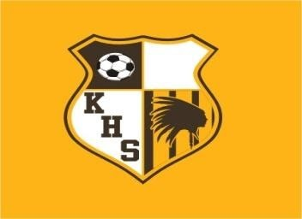

KICKAPOO HIGH SCHOOL
LADY CHIEFS SHOOTOUT 2025

TEAMS PARTICIPATING: Bentonville, Branson, Glendale, Harrison, AR; Hickman, Jackson, Kickapoo, Lee’s Summit West, Nixa, Republic, Rogersville, Smith-Cotton, Timberland

Thursday APRIL 17th

10:00AM Rogersville vs Republic
12:00PM Nixa vs Timberland
2:00PM Bentonville vs Smith-Cotton
4:00PM Kickapoo vs Lees Summit West
6:00PM Timberland vs Jackson
8:00PM Glendale vs Hickman

Friday APRIL 18th

10:00AM Timberland vs Kickapoo
12:00PM LSW vs Nixa
2:00PM Jackson vs Glendale
4:00PM Hickman vs Bentonville
6:00PM Republic vs Harrison, AR
8:00PM Smith-Cotton vs Rogersville

Saturday APRIL 19th

8:00AM Jackson vs Kickapoo Grass
8:00AM Hickman vs Branson Turf
10:00AM Nixa vs Bentonville Grass
10:00AM Glendale vs Smith-Cotton Turf
12:00PM Rogersville vs Harrison, AR Grass

30th Edition

