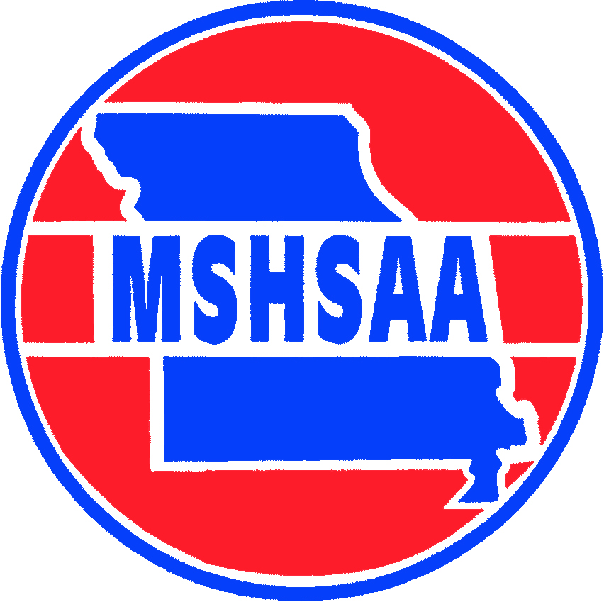

2018 Glendale Varsity Roster

No Name Grade Position

00 Elyssa Hitt 12 K
0 Sophie Talburt 10 K
1 Kayla Brady 09 M
2 Nedia Crawford 12 D
3 Lauren Hamm 09 D
4 Molly Frech 09 D
5 Kayla Broughton 12 F
7 *Alison Hawkins 12 M
8 Chloe Hamm 09 F
9 Marisa Bannigan 12 M
10 Bailey Heinrichs 09 D
11 Madi Marsh 10 D
12 Reagan Richardson 12 F
13 *Mary Powell 12 D
14 Macie Stephens 09 D
15 Makaela Ingemi 12 F
16 Janis Whalen 12 F
17 Jenna Kirtley 09 M
18 Emma Miller 11 F
19 Carson Buzbee 12 F
22 Anna Fredrick 12 F
23 Natalie LaCroix 10 F
* Captains

Head Coach Jeff Rogers
Assistant Coach Logan Bisbee & Nathan Cardoza

